Lab Goal: A review of everything we have learned in the previous Jeroo units.

Lab Description: You must pick all the flowers, destroy all the brick, and end at the bottom right corner facing south

Starting Screen: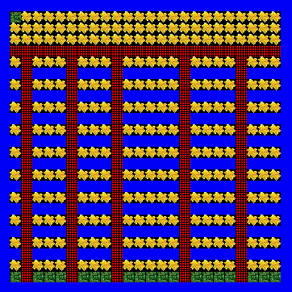

FilesNeeded:JerooProjectMap.jev

*Algorithm Help*

Required Conditionals

* Flower Ahead-Hop, Pick
* Flower Right-Turn Right, Hop, Pick
* Flower Left-Turn Left, Hop, Pick
* Net Ahead-Hop, Toss
* Net Right-Turn Right, Toss
* Net Left-Turn Left, Toss
* Water Ahead-Turn Right, Hop
* Water Right-Turn Left, Hop
* Water Left-Turn Right, Hop

Ending Screen: Post Conditions

* Successfully hop through the nets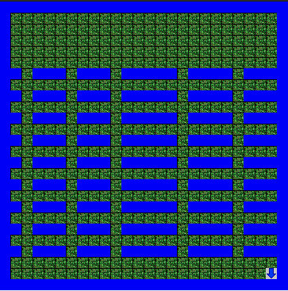
* Jeroo is not in the nets
* Jerro is at the bottom right corner
* Jeroo is facing South
* All flowers are picked